**NGUYEN KIM HOA**

More than 18 years’ experience in R&D Packaging Development at Unilever Vietnam, with areas: Flexible/ Rigid Plastic/ Metal & Glass/ Paper & Board/ Printing & Decoration.

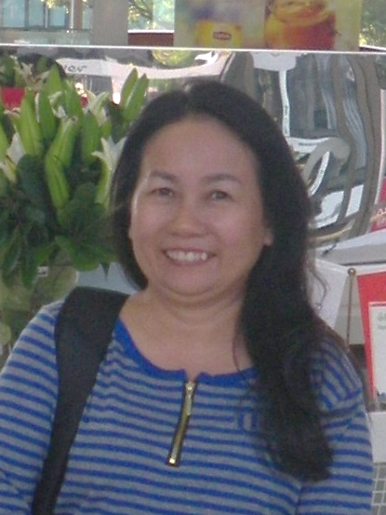

***Contact details:***

Date of birth: 04 May 1967

Address: 25/ 42 Nguyen Binh Khiem Street, Dist. 1, Ho Chi Minh City.

Telephone: 0918069300

E-mail: Nguyenkimhoa.unilever@gmail.com

***Professional Experience:***

* Quality Assurance
* Packaging Designer
* Packaging Development HPC & Foods

***Major achievements***

* Received Special SEAA Director AWARD for “**FOODS GOT TALENT SEAA 2013**” (for Packaging Solutions) & “**FOODS R&D LEADERSHIP TEAM GCSEAA 2015**” (for Packaging specification on the new System)
* Succeeded in Sustainable Packaging Projects – Optimize packaging cost, improve packaging effectiveness and identify cost saving opportunities (over target >10% per year, especially is in Paper & Flexible area)
* Building Packaging capabilities on two groups: Foods SEAA PackNet & Refreshment SEAA PackNet (Packaging Network)
* Leading local team for activations: Consumer & Market understanding and Internal Learning.
* Applying innovations in production with high productivity & great packaging solutions in automation packaging machine.

***Positions Assumed:***

**2007 - Present: Unilever Vietnam**

R&D Packaging Development leader for **Foods (including Food solutions) & Refreshment Vietnam**

*I’m working with 2 roles: RDC (Regional Deploy Center) & TM (Technical Management) role to support Supply chain/ Brand building for innovations/ renovations/ promotions/ activations/ Imported and exported products* incategories: Beverage/ Ice cream/ Savory and total Food solutions (with two subordinates).

**The main tasks/Achievements were:**

* + - * Developing great concepts for packaging from Ideas to Market ready phase with differentiated packs (primary, secondary, tertiary packaging material).
* Ensuring mandatory compliance to Unilever regulatory requirements in terms of safety of Foods packaging.
* Focusing on sustainable materials - Remove PVC and replace by PET film
* Supporting Supply Chain in new factory, carry out all trials with new materials/ machines. Ensuring that the new packaging design is stable at different stages (packing lines/ machines/sites/ 3Ps…).
* Designing technical drawings/ layouts, working with supplier to develop molds, plates, cylinders.
* Identifying cost saving opportunities, cost improvement.
* Improving packaging design to reduce costs, maximize machine capability.
* Managing supplier partnerships, monitoring and following with supplier about rejections/ out of standard materials/ supplier capability.
* Supporting warehouse management in term of pallets and containers pattern: Increase the maximum efficiency of the pallets to comply with the requirements of warehouse while ensuring quality of secondary packaging.
* Defining packaging items/ wasted ratio for components (bill of material), supporting SAP/ IS system.
* Supporting QA in troubleshooting and solving problem. Providing technical insight for field issue resolution, identifying and resolving inherent packaging design. Providing and maintaining accurate packaging standards & capabilities detailing standard material specifications.
* Developing packaging of premium promotions. Conducting detailed specification of all POSM material, reducing the packaging cost through optimal design.
* Monitoring Competitors / Fake products.
* Capturing/ training/ sharing the packaging best practices, coaching the team on the packaging knowledge and packaging technology.

**2005 to 2007**: **Elida P/S & Best Foods Unilever** - **(PC & FOODS)**

R&D Packaging Development leader for **Oral care & Foods Vietnam** (with one subordinate)

*In 2006 I was assigned to take an additional responsibility for Packaging of Best foods: Beverage/ Savory/ Food solutions*

**The main tasks/achievements were:**

* Saving Oral projects: Reducing the thickness of laminate (from 40 to 12 micron)/ Switching from tuck-end to glued end for carton box.
* Exporting Oral more countries, more variants.
* Harmonizing/ simplifying pack types/ pack sizes for Oral packaging
* Switching from packing by manual to automation for of Foods & Beverage (as Oral before).
* Developing the new packaging for new Foods products: Fish sauce (Knorr)/ Snack (Taro) and Food solutions items.

**1997 to 2005**: **Elida P/S Unilever** **– (PC)**

R&D Packaging Development leader

*Unilever established this JV Company with P/S Company in 1997, I was in charge for Packaging development Oral Care: Toothpaste/ Toothbrush/ Mouthwash.*

**The main tasks/achievements were:**

* Supporting to transfer from the old locations of P/S to the new plant, carry out all trials with new Packaging/ machines.
* Responsible for packaging of Oral care local in key projects: Switching from packing by manual to automation/ Change from Aluminum tube to laminate tube/ Change from reverse printing to surface printing on laminate.
* Responsible for packaging of Toothpaste export Thailand in the big project “close Thailand toothpaste factory and move to Vietnam production”, exporting products to many countries: Cambodia/ Pakistan/ Mongolia/ Korea/ Indo/ China…

**Before 1997**: **P/S Company – (HPC**)

Designer/ QA/ Packaging Development

*P/S Company had 4 manufacturing plants, with products being Shampoos/ Detergent pastes / Toothbrushes and mainly Toothpastes with Aluminum Tube making as well as 3 brands: P/S, Hynos and Perlon*.

**The main tasks/achievements were:**

* Designing the zinc plate for toothpaste tube and developing the packaging
* Ensuring the good quality of packaging before production

***Academic Career***

* Graduated from Industrial Art College –1990

Seminars Attended

* Global packaging excellence (Packaging process) Shanghai – China 2016
* Foods Packaging foundation/advance courses Shanghai – China 2014
* Deploy foundation course Bangkok – Thailand 2012
* Advanced Rigid Plastic & Mold maker course Shanghai – China 2009
* HACCP, Risk-based supplier management course Bangkok – Thailand 2008
* Quality in Innovation
* Pelican (SEAC) – Foods grade
* Soft skill (Influencing/Creativity/Persuasion/Thinking/Meeting management/ Project management/ Time Management/Problem-solving/ Planning effect business meeting … )

***Skills***

* + Fully operational in using MS office: Word, Excel, PowerPoint..
  + Working knowledge in using CapePack, Photoshop

***Language***

* English

***Hobby***

* Reading, Music, Painting